


Exploratory Data Analysis and Visualization
Report

1.Muhammad Taifoor
- Swati Mani
- Sania Farheen
- Helen Akpabio Ndarake
- Muhammad Subhan Khan
- Sasikanth Danthanala
- Olawale Owoyomi
- Omotosho Jhonson

WEEK 3 FINAL REPORT –CHURN ANALYSIS AND PRIDICTION MODELING

1. Overview of Week 3 Work
In Week 3, the main goal was to predict student churn (drop-off) using machine learning and to understand why students disengage from opportunities. This work builds on Week 1 (data cleaning and feature engineering) and Week 2 (exploratory data analysis).
Three machine learning models were built and compared:
- Logistic Regression
- Decision Tree
- Random Forest
The models were evaluated using standard performance metrics, and insights were generated to help improve student engagement and retention.
Whole Work Link: https://drive.google.com/drive/folders/1LsKSj1Cri1Akvk27gIiym8bA0Ws8Ocon?usp=sharin g
Code File:
https://drive.google.com/file/d/12G_Te7BQRyDOc0XdZ0JBi-
_HUj4MTbVa/view?usp=sharing

2. Problem Statement Business Problem
Many students register for opportunities but do not complete them. This drop-off (churn) reduces program effectiveness and learner success.

Prediction Problem
The problem is to predict whether a student will churn or not, using:
- Engagement behavior
- Demographic information
- Opportunity characteristics
This is a binary classification problem:
- Churn = 1 → student dropped / rejected / failed to start
- Churn = 0 → student completed or remained active

3. Dataset and What We Predict Dataset Description
Each row in the dataset represents one student’s interaction with one opportunity. The dataset includes:
- Student age, gender, country
- Engagement days and engagement score
- Opportunity category and duration
- Final status of the student
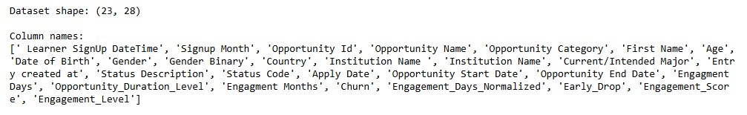
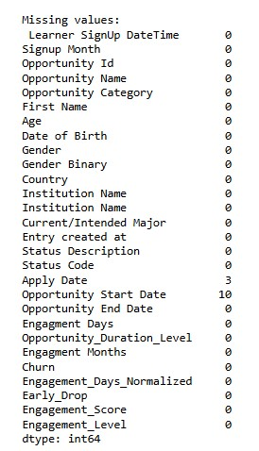
What Is Being Predicted
Using early engagement and background information, the models predict:

Whether a student will churn before completing the opportunity Where Problem Solving Happens in the Dataset
- Engagement features show how active a student is
- Opportunity category shows which programs have higher risk
- Demographics help identify at-risk groups
- Churn label allows supervised learning

4. Data Preparation for Churn Analysis
Before modeling, the dataset was cleaned and prepared:
- Missing values were handled
- Invalid and duplicate records were removed
- Date columns were validated
- Categorical variables were encoded
- Only pre-outcome features were used to avoid data leakage

Engagement Score
An Engagement Score was created using:
- Normalized engagement days
- Early-drop indicator
This score represents how actively a student participated before the outcome.

5. Machine Learning Models Used 1. Logistic Regression
- Used as a baseline model
- Easy to interpret
- Shows how each feature increases or decreases churn risk

2. Decision Tree
- Captures non-linear relationships
- Easy to explain using rules
- Helps understand decision paths

3. Random Forest
- Combines multiple decision trees
- More robust and stable
- Handles complex feature interactions

6. Model Evaluation and Performance
The models were evaluated using:
- Accuracy
- Precision
- Recall
- F1-Score
- ROC-AUC

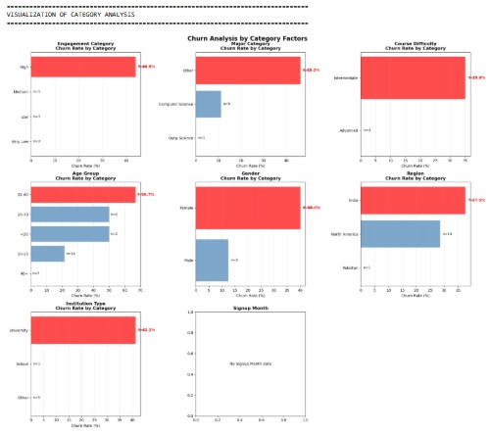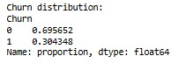
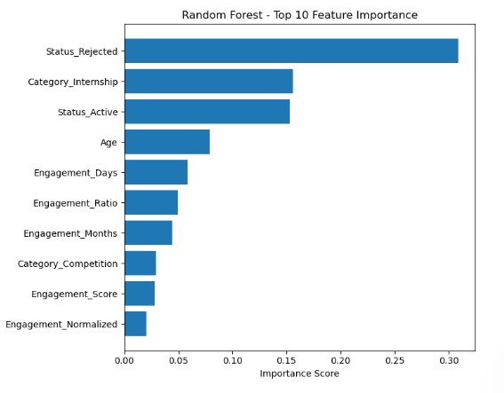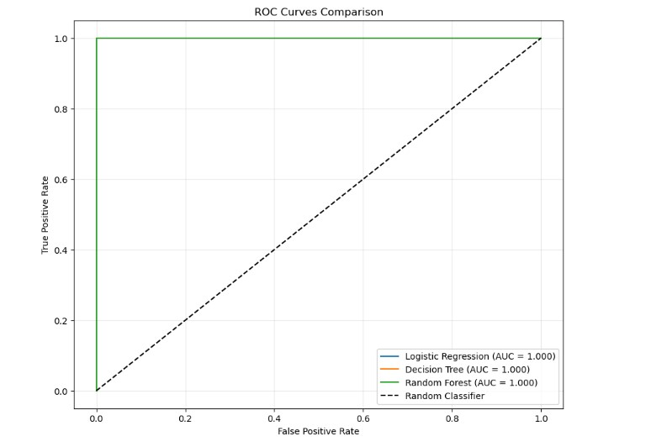

Model Comparison (Summary) Model Performance Notes
Logistic Regression Very strong Stable and interpretable
Decision Tree Very strong Easy to explain
Random Forest Very strong Robust but less interpretable
Because the dataset is small, all models achieved very high scores. These results are treated as proof of concept, not final production performance.

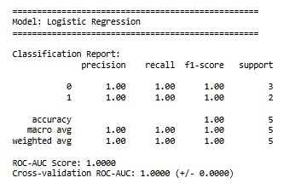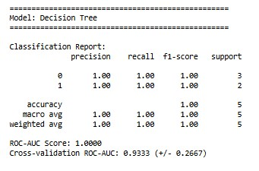

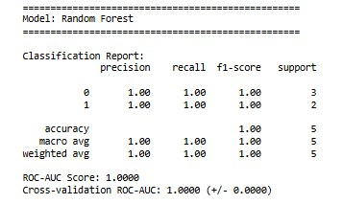

7. Why We Are Comfortable Moving Forward with the Selected Model
Selected Model: Logistic Regression Reasons:
- High and stable performance
- Very easy to interpret
- Clear explanation of churn drivers
- Suitable for academic evaluation
- Easy to deploy and monitor
Although Random Forest also performed well, Logistic Regression provides the best balance between accuracy and explainability.
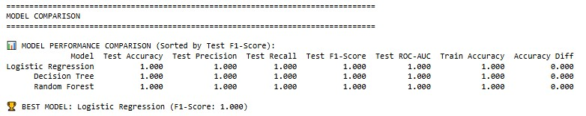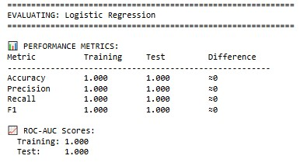

8. Interpretation of Results (Churn Analysis) Key Drivers of Churn
The most important factors linked to churn are:
- Low engagement score
- Early drop-off behavior
- Certain opportunity categories
- Specific age groups
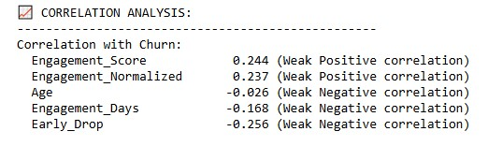

What Problem Is Solved by Each Prediction
- Engagement prediction → identifies students who need early support
- Category prediction → identifies high-risk programs
- Demographic patterns → helps target interventions
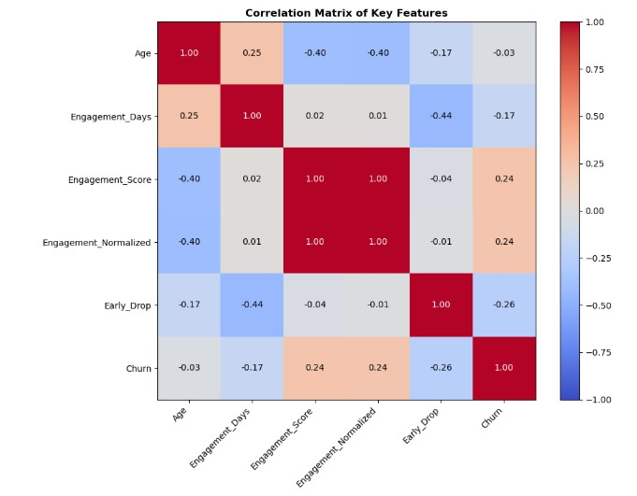

9. Visualization Explanation
The following visualizations were used:
- Model performance tables to compare accuracy and recall
- Feature importance charts to identify churn drivers
- Engagement vs churn charts to show behavior patterns
These visuals help explain results clearly to non-technical stakeholders.

10. Actionable Insights
Key insights from the analysis:
- Students with very low early engagement are most likely to churn
- Medium-engagement students have the lowest churn risk
- Some opportunity categories consistently show higher churn

11. Recommendations (Based on Past Experience) Immediate Actions
- Introduce early-engagement alerts
- Provide extra support during the first few days Process Improvements
- Track engagement daily
- Use churn scores to prioritize at-risk students

Long-Term Improvements
- Integrate churn prediction into the platform
- Continuously retrain models as more data becomes available
- Redesign high-churn opportunity categories
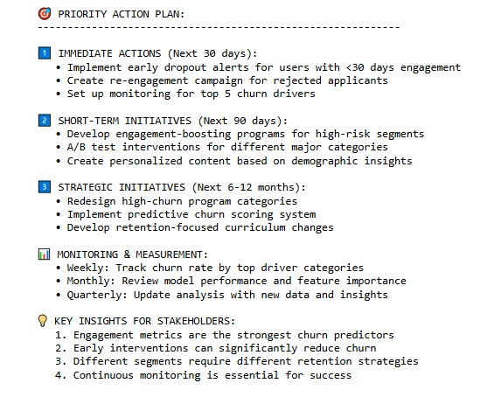

SUMMARY OF KEY FINDINGS

1. TOP CHURN DRIVERS IDENTIFIED:
- Engagement metrics (days, score, early drop)
- Status indicators (rejection, dropout)
- Demographic factors (age)
- Program/category types
2. CRITICAL INSIGHTS:
- Early engagement is crucial for retention
- Different segments require tailored approaches
- Proactive intervention can prevent churn
3. RECOMMENDED FOCUS AREAS:
- Boost early-stage engagement
- Improve application experience
- Personalize based on demographics
- Monitor high-risk segments closely
4. SUCCESS METRICS TO TRACK:
- Reduction in early dropout rate
- Improved engagement scores
- Decreased churn in high-risk categories
- Increased retention across segments

12. Limitations
- Dataset size is small
- Perfect scores suggest possible overfitting

• Results should be treated as a learning and demonstration exercise

13. Conclusion
This Week 3 analysis shows that machine learning can effectively predict student churn using engagement and demographic data. The project demonstrates the complete data science workflow, from data preparation to model evaluation and insight generation.
With more data and continued refinement, this approach can support scalable, datadriven strategies to improve student engagement and retention.

Good day everyone.
My name is Muhammad Subhan Khan, and I will be presenting on behalf of Team 9 for our final project in the Excelerate AI Powered Data Analysis Internship.
The main goal of this work is to understand why students disengage, identify early risk signals, and design practical data-driven solutions that can help reduce drop-offs and improve learning outcomes.

✅ Slide 2 – Team Introduction (about 15–20 seconds)
This project was completed collaboratively by Team 9.
Our team members are:
Muhammad Subhan Khan, Muhammad Tafoor, Sania Farheen, Sasikanth Danthanala, Olawale Owoyomi, Omotosho Johnson, Swati Mani, and Helen Akpabio Ndarake.
We worked together across data preparation, exploratory analysis, predictive modeling and business recommendations.

✅ Slide 3 – Executive Summary (about 40–45 seconds)
In this project, we first prepared and engineered learner and opportunity data, and then explored engagement behavior to identify meaningful patterns and data quality risks.
Based on these insights, we built an interpretable churn prediction model to estimate which students are most likely to disengage.
Our analysis shows that early engagement behavior is the strongest indicator of future drop-off, and that different learner segments require different engagement strategies.
Using these findings, we designed a lightweight recommendation and alert framework that supports early intervention, personalized engagement actions, and data-driven decision making for improving student retention.

This project demonstrates how analytics and simple machine learning can be translated into practical operational strategies for learning platforms.

I would like to thank the Excelerate platform for connecting students from different parts of the world through a single learning environment and providing a well-structured internship experience. The platform made collaboration, task submission, and progress tracking simple and organized. It also helped me stay aligned with weekly goals and clearly understand expectations, which greatly supported my learning and professional growth throughout the internship.
- This internship helped me understand the complete data analytics lifecycle, from data cleaning and feature engineering to exploratory analysis, modeling, and business recommendations.
- Working on real student engagement data made the learning much more practical and relevant.
- The Excelerate platform provided a structured weekly workflow, which helped me stay organized and clearly understand what to deliver each week.
- I found the centralized submission and progress tracking on the Excelerate platform very useful for managing tasks and deadlines.
- Collaborating with an international team through Excelerate improved my teamwork, communication, and coordination skills.
- This internship also improved my ability to explain technical insights in a clear and simple way for non-technical stakeholders.
- Receiving feedback through the Excelerate process helped me understand how to improve both my technical work and presentation skills.
- Overall, the Excelerate internship increased my confidence to work on real-world AI and data analytics projects in a professional environment.
- The team-based project approach helped me learn different perspectives on problem-solving and data analysis.
- I learned how important data quality, validation, and proper preprocessing are before building any predictive model.

